**UJIAN TENGAH SEMESTER**

**“Algoritma”**



**DISUSUN OLEH**

Nama : Arina Saffanah Zakiyyah

NIM : 20220801189

Fakultas : Ilmu Komputer

Program Studi : Teknik Informatika

**Universitas Esa Unggul**

**Tahun Ajaran 2022/2023**

1. **MEMBUAT PROGRAM DERET BILANGAN PRIMA**

#include<iostream>

using namespace std;

int main(){

//MEMBUAT PROGRAM DERET BILANGAN ARITMATIKA

cout<<"============================"<<endl;

cout<<"PROGRAM DERET BILANGAN PRIMA"<<endl;

cout<<"============================"<<endl;

float bil, total = 0, rerata;

cout<<"50 Deret bilangan prima : \n";

cout<<endl;

for(int a = 1 ; a <= 230 ; a++){

//prima hanya punya 2 faktor. 1 dan bilangan itu sendiri.

//JADI ANGKA 1 TIDAK MASUK KE BILANGAN PRIMA

bil = 0;

for(int b = 1; b <= a ; b++){

if (a % b == 0){

bil++;

}

} if (bil == 2){

cout<<a<<" ";

total += a;

} rerata = total/50;

}

cout<<"\n\nTotal deret \t\t= "<<total<<endl;

cout<<"Rata-rata deret \t= "<<rerata<<endl;

return 0;

}

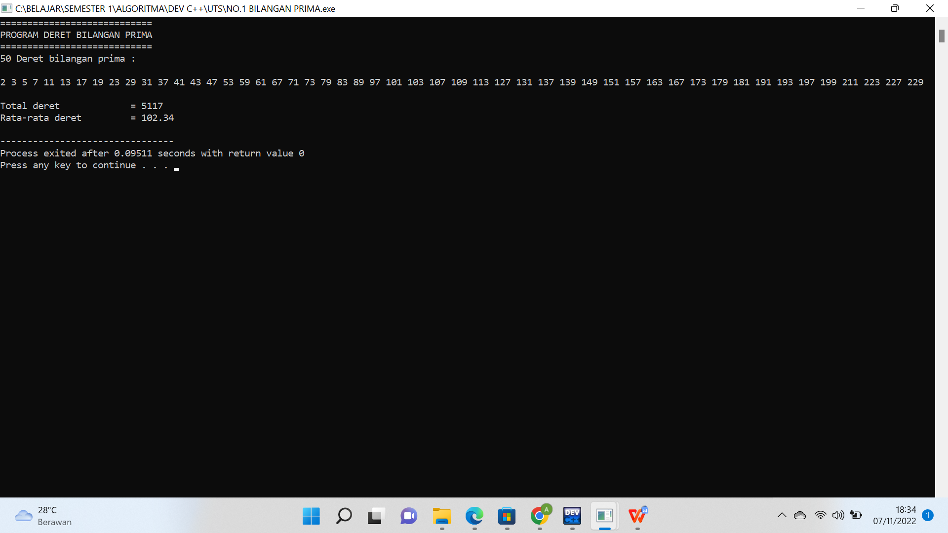

**3A. MEMBUAT PROGRAM ARRAY**

#include<iostream>

using namespace std;

string nama[5] = {"Arina", "Andita", "Reza", "Yoga", "Saffa"};

string nim[5] = {"20220801189", "20220801266", "20220801010", "20220801284", "20220801188"};

int nilai[5] = {100, 88, 78, 65, 85};

string predikat[5];

int jumlahPred1 = 0;

int jumlahPred2 = 0;

int jumlahPred3 = 0;

void mahasiswa(){

for(int a=0; a<5; a++){

nama[a];

nim[a];

nilai[a];

}

}

void proses(){

for(int a=0; a<5; a++){

if(nilai[a]>=88 && nilai[a]<=100){

predikat[a] = "Sangat memuaskan";

jumlahPred1+=1;

} else if(nilai[a]>77 && nilai[a]<88){

predikat[a] = "Memuaskan";

jumlahPred2+=1;

} else if(nilai[a]>=60 && nilai[a]<=76){

predikat[a] = "Cukup";

jumlahPred3+=1;

}

}

}

void output(){

cout<<"-------------------------------------"<<endl;

cout<<" PROGRAM ARRAY "<<endl;

cout<<"ARINA SAFFANAH ZAKIYYAH - 20220801189"<<endl;

cout<<"-------------------------------------"<<endl;

cout<<"\n======================================================== ============================"<<endl;

cout<<" No \t ";

cout<<" NIM \t ";

cout<<" \tNama \t ";

cout<<" \tNilai \t\t ";

cout<<" Predikat \t ";

cout<<"\n======================================================== ============================"<<endl;

for(int a=0; a<5; a++){

cout<<" "<<a+1<<" "<<nim[a];

cout<<" \t"<<nama[a];

cout<<"\t \t"<<nilai[a];

cout<<"\t \t"<<predikat[a]<<endl;

}

cout<<"========================================================== =========================="<<endl;

cout<<"Jumlah predikat yang 'Sangat memuaskan' \t= "<<jumlahPred1<<endl;

cout<<"Jumlah predikat yang 'Memuaskan' \t\t= "<<jumlahPred2<<endl;

cout<<"Jumlah predikat yang 'Cukup' \t\t\t= "<<jumlahPred3<<endl;

}

int main(){

mahasiswa();

proses();

output();

return 0;

}

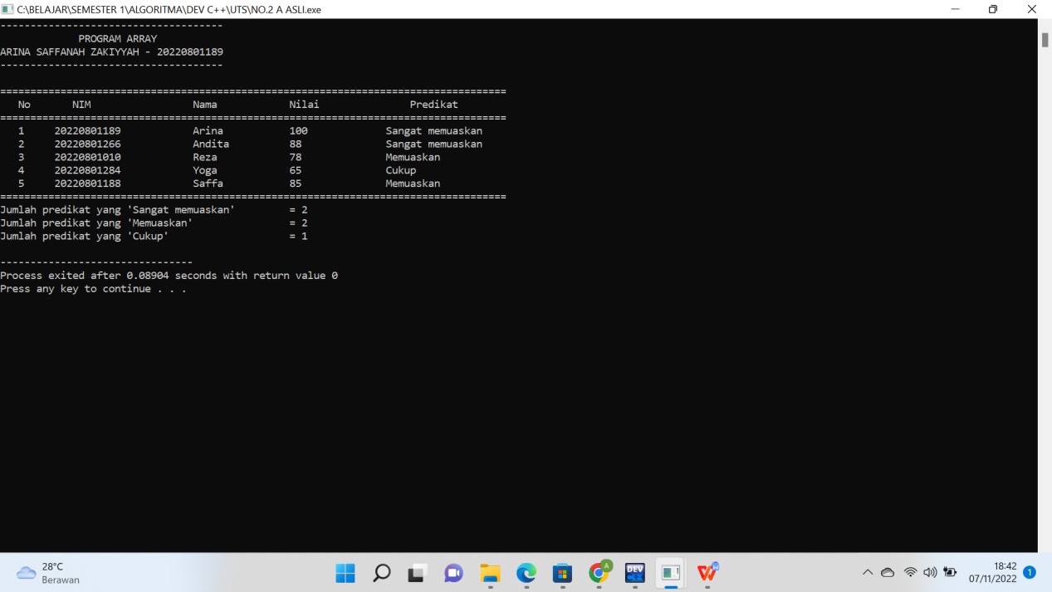

**3B. MEMBUAT PROGRAM ARRAY DARI STRUKTUR**

#include<iostream>

using namespace std;

struct mhs{

string nama;

string nim;

int nilai;

string predikat;

};

mhs input[5];

int jumlahPred1 = 0;

int jumlahPred2 = 0;

int jumlahPred3 = 0;

void mahasiswa(){

input[0].nama = "Arina";

input[0].nim = "20220801189";

input[0].nilai = 100;

input[1].nama = "Andita";

input[1].nim = "20220801266";

input[1].nilai = 88;

input[2].nama = "Reza";

input[2].nim = "20220801010";

input[2].nilai = 78;

input[3].nama = "Yoga";

input[3].nim = "20220801284";

input[3].nilai = 65;

input[4].nama = "Saffa";

input[4].nim = "20220801188";

input[4].nilai = 85;

}

void proses(){

for(int a=0; a<5; a++){

if(input[a].nilai>=88 && input[a].nilai<=100){

input[a].predikat = "Sangat memuaskan";

jumlahPred1+=1;

} else if(input[a].nilai>77 && input[a].nilai<88){

input[a].predikat = "Memuaskan";

jumlahPred2+=1;

} else if(input[a].nilai>=60 && input[a].nilai<=76){

input[a].predikat = "Cukup";

jumlahPred3+=1;

}

}

}

void output(){

cout<<"\n======================================================== ============================"<<endl;

cout<<" No \t ";

cout<<" NIM \t ";

cout<<" \tNama \t ";

cout<<" \tNilai \t\t ";

cout<<" Predikat \t ";

cout<<"\n======================================================== ============================"<<endl;

for(int a=0; a<5; a++){

cout<<" "<<a+1<<" "<<input[a].nim;

cout<<" \t"<<input[a].nama;

cout<<"\t \t"<<input[a].nilai;

cout<<"\t \t"<<input[a].predikat<<endl;

}

cout<<"========================================================== =========================="<<endl;

cout<<"Jumlah predikat yang 'Sangat memuaskan' \t= "<<jumlahPred1<<endl;

cout<<"Jumlah predikat yang 'Memuaskan' \t\t= "<<jumlahPred2<<endl;

cout<<"Jumlah predikat yang 'Cukup' \t\t\t= "<<jumlahPred3<<endl;

}

int main(){

mahasiswa();

proses();

output();

return 0;

}

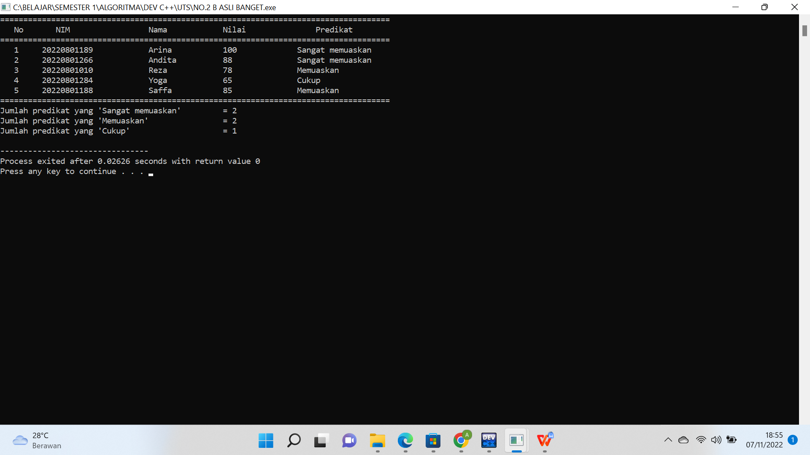

**3C. MEMBUAT PROGRAM ARRAY DARI POINTER**

#include<iostream>

using namespace std;

string nama[5] = {"Arina", "Andita", "Reza", "Yoga", "Saffa"};

string nim[5] = {"20220801189", "20220801266", "20220801010", "20220801284", "20220801188"};

int nilai[5] = {100, 88, 78, 65, 85};

string predikat[5];

string *ptr1 [5];

string *ptr2 [5];

int *ptr3 [5];

string *ptr4 [5];

int jumlahPred1 = 0;

int jumlahPred2 = 0;

int jumlahPred3 = 0;

void mahasiswa(){

for(int a=0; a<5; a++){

ptr1[a] = &nama[a];

ptr2 [a]= &nim[a];

ptr3 [a]= &nilai[a];

ptr4 [a]= &predikat[a];

}

}

void proses(){

for(int a=0; a<5; a++){

ptr1[a] = &nama[a];

ptr2 [a]= &nim[a];

ptr3 [a]= &nilai[a];

ptr4 [a]= &predikat[a];

if(nilai[a]>=88 && nilai[a]<=100){

predikat[a] = "Sangat memuaskan";

jumlahPred1+=1;

} else if(nilai[a]>77 && nilai[a]<88){

predikat[a] = "Memuaskan";

jumlahPred2+=1;

} else if(nilai[a]>=60 && nilai[a]<=76){

predikat[a] = "Cukup";

jumlahPred3+=1;

}

}

}

void output(){

cout<<"-------------------------------------"<<endl;

cout<<" PROGRAM ARRAY "<<endl;

cout<<"ARINA SAFFANAH ZAKIYYAH - 20220801189"<<endl;

cout<<"-------------------------------------"<<endl;

cout<<"\n======================================================== ============================"<<endl;

cout<<" No \t ";

cout<<" NIM \t ";

cout<<" \tNama \t ";

cout<<" \tNilai \t\t ";

cout<<" Predikat \t ";

cout<<"\n======================================================== ============================"<<endl;

for(int a=0; a<5; a++){

ptr1[a] = &nama[a];

ptr2 [a]= &nim[a];

ptr3 [a]= &nilai[a];

ptr4 [a]= &predikat[a];

cout<<" "<<a+1<<" "<<*ptr1[a];

cout<<" \t"<<*ptr2 [a];

cout<<"\t \t"<<*ptr3 [a];

cout<<"\t \t"<<*ptr4 [a]<<endl;

}

cout<<"========================================================== =========================="<<endl;

cout<<"Jumlah predikat yang 'Sangat memuaskan' \t= "<<jumlahPred1<<endl;

cout<<"Jumlah predikat yang 'Memuaskan' \t\t= "<<jumlahPred2<<endl;

cout<<"Jumlah predikat yang 'Cukup' \t\t\t= "<<jumlahPred3<<endl;

}

int main(){

mahasiswa();

proses();

output();

return 0;

}

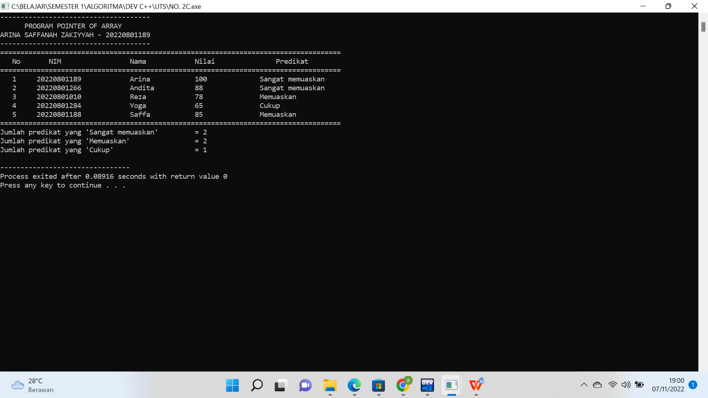

1. **SEARCHING ARRAY & SORT ARRAY**

#include <iostream>

#include <string.h>

#include <iomanip>

using namespace std;

void print(string nama[], int n){

cout<<"Index \t: ";

for (int i = 0; i < 9; i++){

cout<<setw(10)<<i;

}

cout<<"\nNama \t: ";

for (int i = 0; i < n; i++){

cout<<setw(10)<<nama[i];

}

cout<<"\n\n";

}

void a(string nama[], int n){

int idx[n], nFound=0;

cout<<"A. Data yang dicari Huruf huruf ke 3 dan 4 adalah : \n";

for (int i = 0; i < n; i++){

if(nama[i].substr(2, 2)=="na"){

idx[nFound++] = i;

cout<<" "<<nama[i]<<" ";

}

}

cout<<"\n Data ditemukan pada index ke ";

for (int i = 0; i < nFound; i++){

if(i==nFound-1){

cout<<"dan "<<idx[i];

} else {

cout<<idx[i]<<", ";

}

}

cout<<"\n\n";

}

void desc(string nm[],int n){

string nama[n];

for (int i = 0; i < n; i++){

nama[i] = nm[i];

}

cout<<"B. Data sebelum disort :\n";

cout<<" Nama : ";

for (int i = 0; i < n; i++){

cout<<setw(10)<<nama[i];

}

cout<<"\n";

for (int i = 0; i < n-1; i++){

int min=i;

for (int j = i+1; j < n; j++){

if(nama[min].compare(nama[j])>0){

min = j;

}

}

string temp = nama[min];

nama[min] = nama[i];

nama[i] = temp;

}

cout<<"\n Data setelah disort secara Ascending :\n";

cout<<" Nama : ";

for (int i = 0; i < n; i++){

cout<<setw(10)<<nama[i];

}

cout<<"\n\n";

}

void asc(string nm[],int n){

string nama[n];

for (int i = 0; i < n; i++){

nama[i] = nm[i];

}

cout<<"C. Data sebelum disort :\n";

cout<<" Nama : ";

for (int i = 0; i < n; i++){

cout<<setw(10)<<nama[i];

}

cout<<"\n";

for (int i = 0; i < n-1; i++){

int min=i;

for (int j = i+1; j < n; j++) {

if(nama[min].compare(nama[j])<0){

min = j;

}

}

string temp = nama[min];

nama[min] = nama[i];

nama[i] = temp;

}

cout<<"\n Data setelah disort secara Descending :\n";

cout<<" Nama : ";

for (int i = 0; i < n; i++) {

cout<<setw(10)<<nama[i];

}

cout<<"\n\n";

}

int main(){

int n = 9;

string nama[n] = {"Zainab", "Yunarso", "Jojon", "Tinatun", "Qinanti", "Mintarso", "Janah", "Jonathan", "Junaidi"};

print(nama, n);

a(nama,n);

desc(nama,n);

asc(nama,n);

return 0;

}

